AD111
Photomultiplier Amplifier
USB 2.0

User Manual

Ver. 1.1

1. Introduction. 4
1.1. Mission Statement 4
1.2. Warranty 4
1.3. Copyrights 4
1.4. Product Overview 5
1.5. Product Specifications 5
1.6. Controller Box Connectors 5
1.6.2. Rear of Controller Box 5
1.6.2. Front of Controller Box 5
2. Installation. 6
2.1. Checking System Requirements 6
2.1.1. Requirements for the Hardware 6
2.1.2. Requirements for Software 6
2.1.3. Checking System Package Contents 6
2.2. Installing Software 6
2.3. HardWare SetUp 6
USB Installation Pop-up Windows 7
3. Getting Started 8
3.1. The Mouse 8
3.2. The Drop-down Menu 8
3.3. Menus, Tool Bar, Controls and Indicators 8
3.3.1. Menus 8
3.3.1.1. File Menu 8
3.3.1.2. Operate Menu 9
3.3.1.3. Windows Menu 9
3.3.1.4. AD111 Menu 10
3.3.1.5. CmDk Menu 11
• Calibrate 11
o CM-Series 11
o DK-Series 11
• Echo. 11
• Flush. 11
• Goto. 11
• Reset. 11
• Select. 11
• Zero. 12
o CM-Series 12
o DK-Series 12
• Query (only CM-Series). 12
• Units.(only CM-Series). 12
• SlitsAdj.(only DK-Series). 12
• GrtID. 12
3.3.1.5. Help Menu 13
3.3.2. Toolbar 14
3.3.2.1. Description 14
3.3.2.2. Running VI 14
3.3.3. AD111 Controls and Indicators 15
3.3.3.1. Graph Control 16
3.3.3.2. Data Collection Options 17
4. Troubleshooting 18
4.1. No communication with AD111 18
4.2. No communication with Monochromator 18
Appendices 19
Appendix A: RS-232 Serial & USB 2.0 Ports 19
A.1. USB2.0 PINOUT 19
A.2. RS232 PINOUT 19
A.3. RS232 Data Format 19
A.4. RS232 Baud Rate 19
Appendix B: AD111 Reference Drawings 20
B.1. Mechanical Drawings 20
B.2. Electronic Drawings 21
Appendix C: SP SDK Functions 23
C.1. Some basic fundamentals of utilizing the SP SDK functions 23
C.2. SDK Function Descriptions 23
spTestBoard 23
spCloseEx 23
spSetHv 23
spSetRC 24
spSetGain 24
spSetTrigLevel 24
spSetTrigSource 25
spHvSource 25
spMonSource 25
spSetAvg 26
spReadDataEx 26
spReadInfo 27

1. Introduction.

1.1. Mission Statement
Our mission is to provide our customers with reliable products, on time, and at a fair price. We are continually striving to maintain the highest standards, by assuring defect-free products and by providing prompt and courteous customer service.
The staff at Spectral Products will be happy to answer any questions about our products and our services. For immediate assistance, please contact the Spectral Products Group directly at (505) 343-9700, by fax (505) 343-9705, or by e-mail at sales@spectralproducts.com

1.2. Warranty
This product is warranted to be free of defects in materials and workmanship for one year from date of purchase.
This manual and the software it describes are provided free of charge as a service to the customer. The software is intended to be used as a tool for development and as an example of one possible method of code implementation. It is not intended to be a “user application.”
Any software associated with this product is provided “as is” with no warranty, expressed or implied. While it is Spectral Products’ intent to provide error-free development tools, no guarantee is made regarding either the accuracy or usefulness of this material.
Failures or damages resulting from lack of operator attention to proper procedures, failure to follow operating instructions, unauthorized modifications, and natural disasters are not covered under this warranty.
The AD111 does not contain any user serviceable parts. Removing its cover, without explicit written permission from Spectral Products, will void any written or implicit warranty.
Spectral Products reserves the right, without prior or further notice, to make changes to any of its products described or referred to herein to improve reliability, function, or design.
Spectral Products accepts no liability for incidental or consequential damages arising from the use of this software.
Spectral Products does not recommend the use of its components or software products in life support applications wherein a malfunction or failure of the product may directly threaten life or result in injury.
Spectral Products does not recommend that this product be used on the same power line as other equipment with high current draw requirements.

1.3. Copyrights
Spectral Products maintains the copyright on this material, but grants the customer rights to use or to modify the software described herein without obtaining Spectral Products permission and without the requirement to reference Spectral Products as the source of the material.
LabVIEW® is a registered trademark of National Instruments.
Windows™, Microsoft® Visual Basic™ and Microsoft® Quick Basic™ are registered trademarks of Microsoft Corporation.

1.4. Product Overview
The AD111 is a convenient computer controlled photomultiplier detection system for use with Spectral Products’ Digikrom line of monochromators. It features a detector housing that has a dynode divider chain and direct anode connection, mounts directly to exit-slit ports of Digikrom monochromators, and accommodates side-on photomultiplier tubes. (PMT’s must be ordered separately.) It also features the Photomultiplier Amplifier, a compact electronic unit containing the preamplifier and high voltage power supply for the PMT. Coaxial cables for the high voltage and PMT output current signals connect between the detector housing and the amplifier unit. The entire operation, including wavelength and bandpass selection, is controlled with a customer-supplied PC. (The Digikrom monochromator and the AD111 utilize one serial for monochromator and one USB port for AD111) An easy to use program is also included that allows full control of both PMT and monochromator. It graphically displays wavelength versus intensity, intensity versus time and allows ASCII data storage for importing to other user interfaces as desired.

1.5. Product Specifications

- Wavelength Range: per PMT detector.
- High Voltage Range: 0-1000 VDC
- A/D Resolution: 16 bit (Successive Approximation)
- Response Rate: USB 2.0
- High Voltage Resolution: 244 mV
- Data Resolution: 76.3 uV, (data range = 0-5V)
- Time Constant per step: Selectable from 1us to 10 ms
- Conversion time: 2us (Maximum)
- USB 2.0 Transfer Rate: 480 Mbits/sec
- Amplification Gains: x1 to x10 (programmable)
- Supply Voltage: 100-240 VAC
- Current Input Range: 0 to -5μ amps

1.6. Controller Box Connectors

Rear of Controller Box
- J2 Power Connector: Connects to a PUP30-32 switching power supply.
- HV_Ctrl: Is an external input between 0-10 Vdc, and controls the high voltage between 0-1000 Vdc.
- Trig_In: Is a TTL external input between 0-5 Vdc, and keeps the data acquired in wait mode until this input goes to high level.
- HV_Mon: Is an output between 0-10 Vdc, which corresponds to 0-1000 Vdc.
- Sig_Out: Is an output between 0-4.1 Vdc.
- Trig_Out: Is a TTL output between 0-4.1 Vdc, and gives a short high pulse when data is acquired.

Front of Controller Box
- HV_Out: Is a negative output voltage between 0-1000 Vdc, and connects to PMT high voltage connector.
- Sig_In: Is a current input signal between 0-5 uA, and connects to PMT signal connector.
- USB: Is a USB connector, and connects to a USB computer port.

2. Installation.

2.1. Checking System Requirements
Check to make sure that your computer meets the minimum requirements for the AD111CMDK system.

2.1.1. Requirements for the Hardware
- 1 serial port for monochromator communication
- 1 USB for AD111 communication
- A mouse or any other pointing device
- A VGA, SVGA display, or 1024x768
- Any IBM compatible machine with an 80486 processor or higher

2.1.2. Requirements for Software
- Minimum of 32 MB of RAM recommended.
- A hard disk with at least 10MB free space, and 7MB for installation.
- Microsoft Windows 2000 or newer in standard or enhanced mode.

2.1.3. Checking System Package Contents
Check to make sure that your package contains all of the following components. The AD111 system consists of:
- 1 AD111 Photomultiplier Amplifier
- 1 BNC Signal Cable
- 1 SMB High Voltage Cable
- 1 RS232- 9 Pin Cable
- 1 USB cable
- 1 AD100 Photomultiplier Tube
- 1 AD111 controller with a wall plug power supply.
- 1 Software CD

2.2. Installing Software
The software that will control the AD111 Photomultiplier Amplifier is available on the Spectral Products CD Software. Insert CD into the Drive and choose “run” from the file menu of the Microsoft Windows Program Manager or File Manager. Type D:\CDSoftware.exe on the line, and click “OK” to continue. If CD disk drive is different, replace D: with an appropriate drive letter. The CD Software main menu will appear with the software selections available. Check the AD111/CM/DK Executable box to download the LabView 6i software that will run the AD111 as a stand-alone or interfaced with our DK or CM Series Monochromators. The source code for the executable is also available on CD. If you do not have LabView 6i loaded on your system, you will need to download LabView’s 6i Runtime Engine, also available on the CD.

Attention: Software needs to be installed first before installing the hardware

2.3. Hardware Setup
The AD111 internal power supply can handle voltages from 100VAC to 240VAC. Make sure you have the appropriate AC cord. Insert the photo tube inside the PMT tube. Extreme care must be taken when handling the photomultiplier tube (fingerprints may cause serious degradation in the tube performance). For the AD111 Stand Alone application, one USB cable must be connected from the computer USB port to the AD111 USB port. If the AD111 is used with a monochromator, a RS232 cable must be connected from the computer com port to the monochromator. Make sure that the com and USB ports on the computer do not have any IRQ conflicts. Attach the signal and High Voltage cables from the AD111 to the PMT

USB Installation Pop-up Windows
After you connect all power supply cables to AD111 controller, monochromator, and a RS232 cable to monochromator, then the last one is USB cable from computer to AD111 controller box. The first connection to USB AD111 controller from a computer, a user will get all the following windows if you use XP windows.
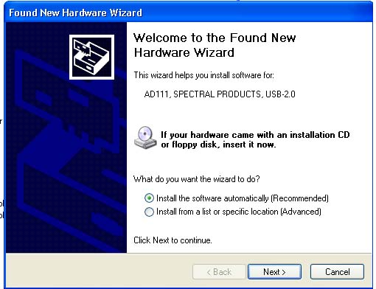
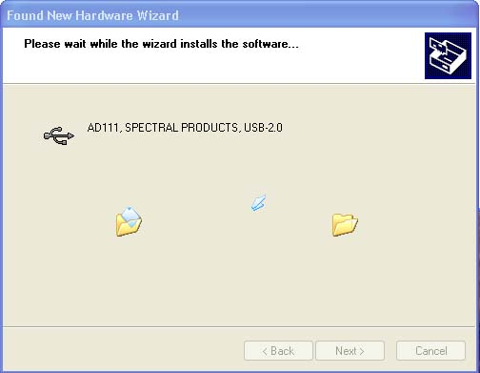

1. Welcome to the Found New Hardware Wizard 2. Found New Hardware Wizard
Click ‘Next’ to continue Do nothing

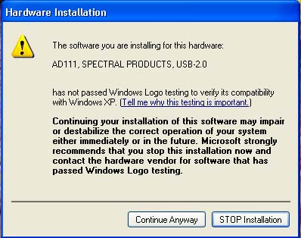
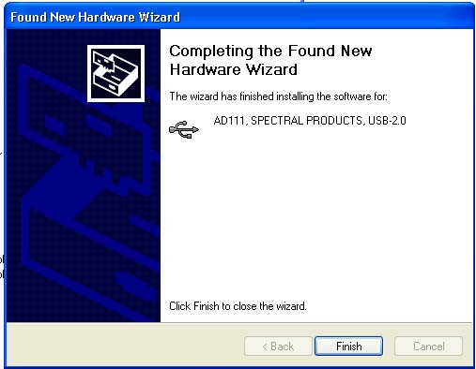

3. Hardware Installation 4. Found New Hardware Wizard
Click ‘Continue Anyway’ Click ‘Finish’

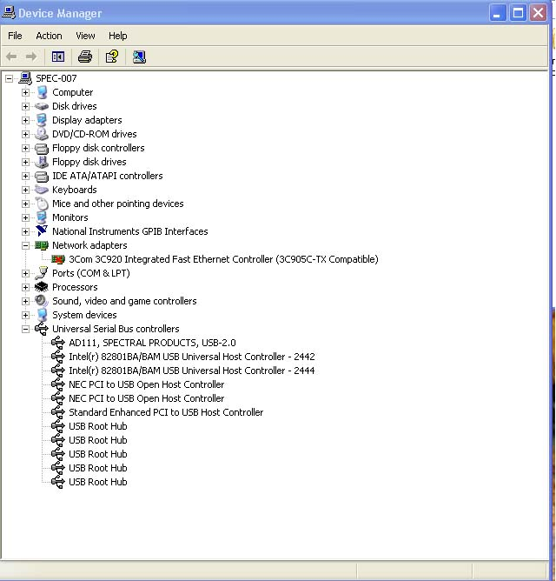
5. On ‘Device Manager’ window, you should see the line ‘AD111, SPECTRAL PRODUCTS, USB 2.0’
6. If you do not see the line, unplug the power supply and USB cable to AD111 controller, and then plug back in the two cables.
7. If you still do not see the line, call Spectral Products for support.

3. Getting Started
Once the hardware and software have been set, you are ready to get started.

3.1. The Mouse
The mechanics of using a mouse with the AD111/CMDK software conforms to the Microsoft Windows standard. The following conventions are used in the manual when explaining manipulations with the mouse: “Clicking” the mouse on an object consists of moving the mouse cursor until it is pointing to the object and depressing the specified mouse button once or twice in quick succession. If you have reconfigured your mouse for other-handed use, switch the references (specified or assumed) to the right and left buttons.

3.2. The Drop-down Menu
Menu options are referenced as “to level menu”: “submenu option” likes these following examples:
File
Open… is referenced as File:Open…

Help
Show Help is referenced as Help: Show Help

3.3. Menus, Tool Bar, Controls and Indicators
This section has detailed descriptions about the menus, tool bar, controls and indicators. For each menu, a brief description of each command is given. In addition, LabVIEW programs are called virtual instruments (VIs).

3.3.1. Menus

3.3.1.1. File Menu
- Open. Displays data from a x, y data file to the graph
- Save. Saves the current x, y data on the screen into 'x tab y' format file.
- Close. Closes the active window and does not save any changes you have made.
- Printer Setup… Sets configuration options for the printer. You can change the orientation of printout (landscape versus portrait). Printer Setup settings are saved with your VI.
- Print Window… Prints out the contents of the currently active window. Using this option, you can make a quick printout with the minimum number of prompts.
- Exit. Quit LabVIEW.

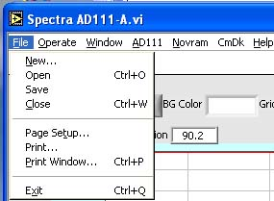
Fig. 1. File Menu

3.3.1.2. Operate Menu
- Run. Executes the current VI.
- Stop stops the VI before it completes execution. Avoid using the Stop menu item to quit a VI, because it can leave your system in an unstable state. You should use an Exit switch to stop theVI that continuously executes.
- Print at Completion. Prints the contents of a VI’s front panel after each execution.
- Log at Completion. Logs a time stamp and the data in all front panel controls of a VI to a separate datalog file.
- Data Logging. Displays data logging options. (Optional if you have LabVIEW software).
- Reinitialize All to Default. Sets all controls and indicators to their default values
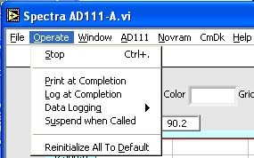

Fig. 2. Operate Menu

3.3.1.3. Windows Menu
- Show VI Info... Displays the VI file path, revision number, and memory usage.
- Show Clipboard. Displays the contents of the clipboard.
- Full Size. Uses the entire screen to display the active window.

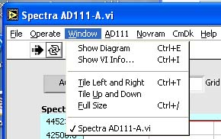

Fig. 3. Window Menu

AD111 Menu
All information about AD111.
- ADstatus. Reads the data saved in the Eeprom. They are high voltage, RC constant, gain, trigger value, trigger source, HV source, HV control source, firmware version, DC power, and sample average.

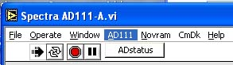

Fig. 4. AD111Status

3.3.1.5. Novram Menu
Access to nonvolatile memory by using read and write novram commands.
- NovRead. Reads the memory values from Novram chip, and displays the values on the read Novram window.
- NovWrite. Uses this command to write 128 (0-127) bytes to the monochromator's non-volatile memory.

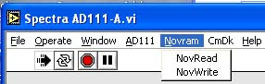

Fig. 5. Read & Write Novram

3.3.1.5. CmDk Menu

The dropdown menu controls and calibrates the CM or DK monochromator.
- Calibrate. Allows recalibration of the monochromator positioning scale factor and should always be used immediately after using the ZERO command.
- CM-Series
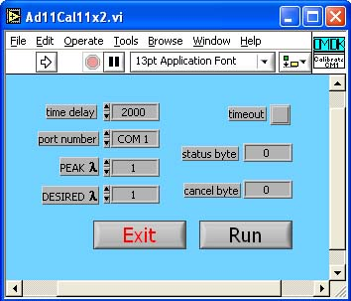

PEAK λ - Is the maximum of the spectral line shown on the graph
DESIRED λ – Is the theory peak wavelength that is used to rescale the calibration factor
Run – Inputs the Desired λ to monochromator and rescale with the current wavelength..
Exit – closes the Command window

- DK-Series
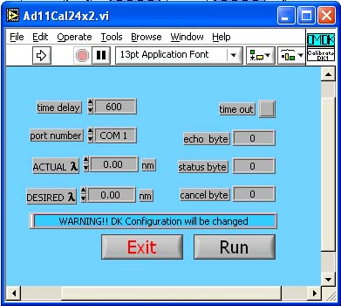

ACTUAL λ - Is the maximum of the spectral line shown on the graph
DESIRED λ – Is the theory peak wavelength that is used to rescale the calibration factor
Run – Inputs the Desired λ to monochromator and rescale with the current wavelength..
Exit – closes the Command window

- Echo. Is used to verify communications with the monochromator.
- Flush. Cleans the serial communications receiver buffer.
- Goto. Moves the monochromator to a selected position.
- Reset. Returns the grating to home position.
- Select. Selects the grating that will be used.
- Zero. Allows the recalibration of the position of the zero order transmission of the monochromator.
- CM-Series
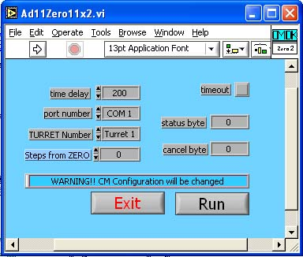

TURRET Number – Uses to select Turret 1, Turret 2, or both if you have CM112. For CM110, Turret 1 is the right one.
Steps from Zero – Are the number of steps from the peak of a zero scan graph.
Run – Sets the new zero position at the ‘Steps from Zero’ position.
Exit – Closes the Command window

- DK-Series
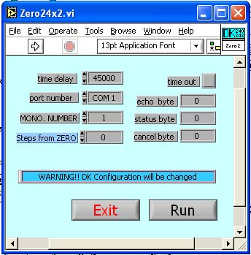

MONO Number – Uses to select 1 or 2 if you have DK242. For DK240 or DK480, 1 is the right selection.
Steps from Zero – Are the number of steps from the peak of a zero scan graph.
Run – Sets the new zero position at the ‘Steps from Zero’ position.
Exit – Closes the Command window

- Query (only CM-Series). Displays the monochromator status.
- Units.(only CM-Series). Allows the selection of units used in the Goto, Scan, Size, and Calibrate commands.
- SlitsAdj.(only DK-Series). Adjusts all slits to a given width.
- GrtID. Returns the six byte current grating ruling identifier.

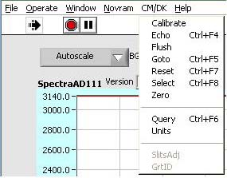

Fig. 6. CM/DK Command Menu

Help Menu

- Show Context Help. Is a Context-sensitive Help window that displays a function’s or VI’s parameters, parameter type definitions, and the description for the object.
- Lock Context Help. Locks the current contents of the Context Help window. With this item active, moving the cursor over different front panel or block diagram object does not change the contents of the Context Help window.
- Contents and Index. Accesses the full LabVIEW Help electronic documentation.
- About-Information on LabVIEW software version number and serial number.

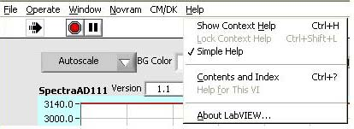

Fig. 7. Help Menu

3.3.2. Toolbar

3.3.2.1. Description
The LabVIEW toolbar contains four command buttons as in figure 8
.
Fig. 8. LabVIEW Toolbar
Run button. Runs the VI.

Run Continuously Runs the VI until you abort or pause execution.
Abort Execution aborts execution of the top-level VI. If more than one running top-level VI uses the VI, the button is dimmed.
Pause/Continue button. Pauses VI execution/Continue VI execution.

3.3.2.2. Running VI
You can run a VI by selection Operate:Run or clicking on the run button.

While the VI is executing, the run button changes appearance. If the Vi is running at its top level, the run button looks like the illustration shown to the left.
If the VI is executing as a sub VI, the run button changes to look like the illustration shown to the left.

AD111 Controls and Indicators

The main window of the AD111 software is (SP AD111.vi) as shown in figure 9.

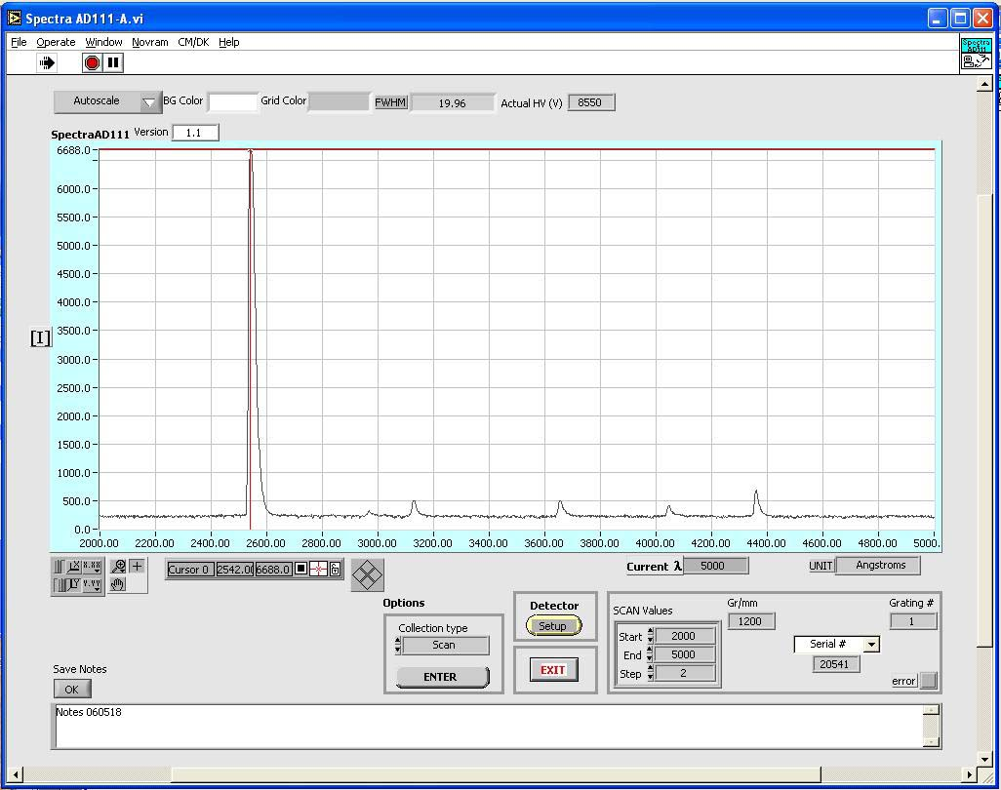

Figure 9. AD111 Main Screen

In the main screen, there are graph, graph control, collection type, detector setup, SCAN Values, Monochromator properties, Current λ, unit, notes, autoscale control, BG color, grid color, FWHM, Actual HV, and ms to get each Data.

3.3.3.1. Graph Control
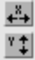
AutoScale (X or Y) - Turns autoscaling on or off. If pressing the X AutoScale button, shown at the left, the graph AutoScale the x-axis. If pressing the y AutoScale button, the graph AutoScale the y-axis.
Lock Scale - Clicking the lock switch, the graph will continuously autoscale.

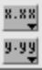
Scale Format - Maintains run-time control of the format of the x and y scale markers respectively.


In standard operate mode, the plus or crosshatch is indicated. In operate mode, you can click in the graph to move cursors around.


Panning Tool - Switches to a mode in which you can scroll the visible data by clicking and dragging the plot area of the graph.

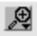
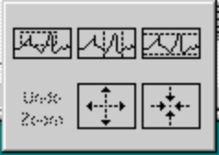
Zoom Tool - Zooms in or out on the graph. Clicking the zoom tool, you see a pop-up menu to choose methods of zooming. This menu is shown in the following illustration.

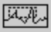
Zoom by rectangle.

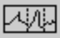
Zoom by rectangle, with zooming restricted to x data (the y scale remains unchanged)

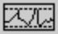
Zoom by rectangle, with zooming restricted to y data (the x scale remains unchanged)

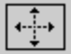
Zoom in about a point. If you hold down the mouse on a specific point, the graph continuously zooms in until you release the mouse button.

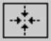
Zoom out about a point. If you hold down the mouse on a specific point, the graph continuously zooms out until you release the mouse button.


Cursor movement control.

Cursor name
X position
Y position
Select button for cursor movement.
Cursor display control
Lock control

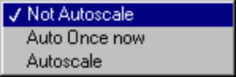
The control to fit Y scale to data: Not autoscale, Autoscale once now, and Autoscale.

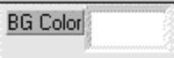
Controls the background color for plotting surface.

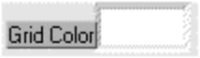
Controls the grid color.

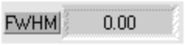
Is the Full Width at Haft Maximum of the highest bell shape on the graph.

Is the voltage that reads from the PMT.

3.3.3.2. Data Collection Options
There are two options: ZeroScan and Scan. In order to activate one of the options, you have to do two steps. First, select the collection type. Second, click on ENTER button.
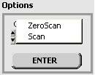
ZeroScan – Scans the monochromator above and below zero order with the number of steps in the ‘Steps Below 0’ box.
Scan – Scans the monochromator from the ‘Start’ to the ‘End’ wavelength, with the increment in ‘Step’.

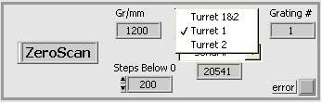
Gr/mm - Is the current grating ruling (g/mm).
Grating # - Is the number of grating currently being used
Serial # - Is the serial number of the monochromator.
Error - Is an indicator, being red if an error occurred
Steps Below 0 - Sets number of steps below and above 0nm for zero scan.
Turrets - Activates the specified turret in zero scan mode.
The selections are:
0: Turret 1&2
1: Turret 1 ( default).
2: Turret 2.
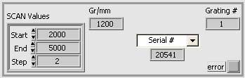
Start - Is the start position at which the scan is to begin.
End - Is the end position at which the scan is to stop.
Step - Is the step size of the current scan.

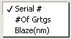
Info – Is able to display Serial number, number of gratings, and the current grating blaze angle.

ms to get each Data – Allows a user to pause between the grating step and the time to acquire data. The number defaults to 0.

Troubleshooting

No communication with AD111
- Verify USB cable between computer and AD111 is properly attached.
- Check AC line voltage.
- Check for USB driver. With windows XP, select Start | Control Panel | System | Hardware | Device Manager. And, Expand the ‘Universal Serial Bus controllers’ folder by clicking the plus sign to find the AD111 driver by searching the name "AD111 PMT, SPECTRAL PRODUCTS, USB-2.0". If you do not see the name, unplug the USB & power cables. Then, plug them back in. If you still cannot find the name, reinstall the AD111 driver.
- The AD111 does not have user serviceable parts. Please call Spectral Products directly at (505) 343-9700 for service.

No communication with Monochromator
- Verify RS232 cable between computer and monochromator is properly attached.
- Check for appropriate COM port and/or IRQ conflict.
- Unplug AC cord and check all connections.

Appendices

Appendix A: RS-232 Serial & USB 2.0 Ports

A.1. USB2.0 PINOUT
(See Table 1 and Figure 1)
The USB connection requires a cable with a USB type B connector at the Spectrometer, and a computer USB port type A.. Spectral Products offers a USB 2.0 plug type A to plug type B cable for connecting to AT, PS2 and MAC style computers, respectively.

Pin Assignments for the USB Connector at one end of AD111 controller
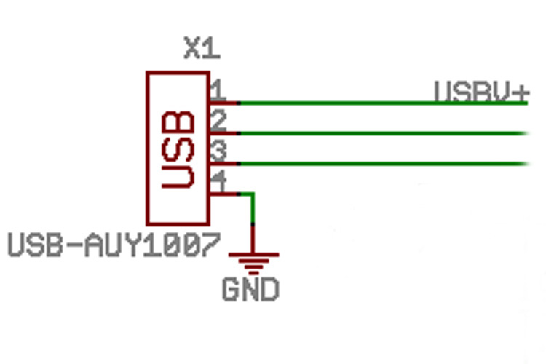
Pin | NAME
1 | USB Power
2 | Data out
3 | Data in
4 | GND

Table 1. USB Pin Function Figure 10. USB Pinout

A.2. RS232 PINOUT
(See Table 2 and Figure 11)
The AD111 uses pin2, pin3, pin6, pin7, and Gnd.

A.3. RS232 Data Format
The AD111 uses the RS232 protocol to communicate between the monochromator and the computer. Specifically, 10 bits are transmitted for each data byte sent or received, and they are transmitted in the following order: one start bit, 8-bit data with the least significant bit transmitted first and the most significant bit transmitted last, and one stop bit.

A.4. RS232 Baud Rate
The transfer rate between the PC and the AD111 is 9600 bits per second (bps).
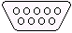
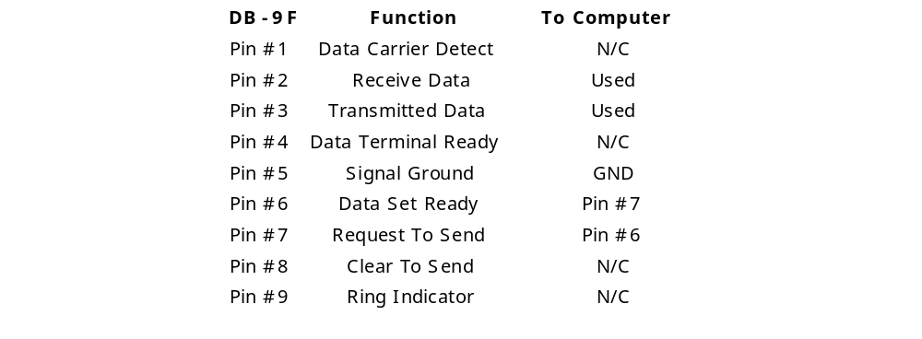 Table 2. FIG. 11
6
9
1
5

Appendix B: AD111 Reference Drawings

B.1. Mechanical Drawings

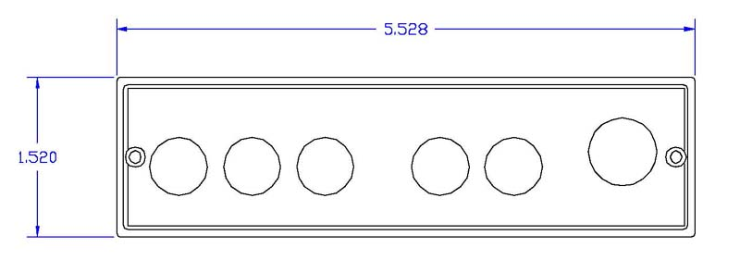
Trigger Output
Power
HV Monitor
Signal Output
Trigger Input
HV Control

Figure 12. AD111 End Plate A

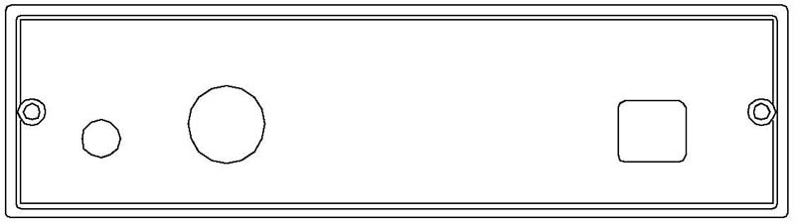
PMT Signal Input
HV Output
USB Connector

Figure 13. AD111 End Plate B

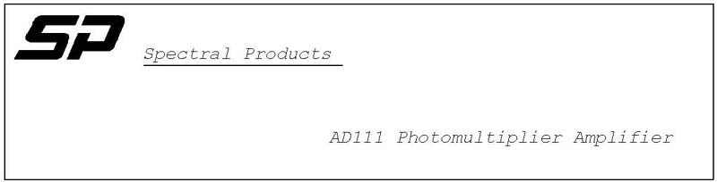

Figure 14. AD111 Logo

B.2. Electronic Drawings

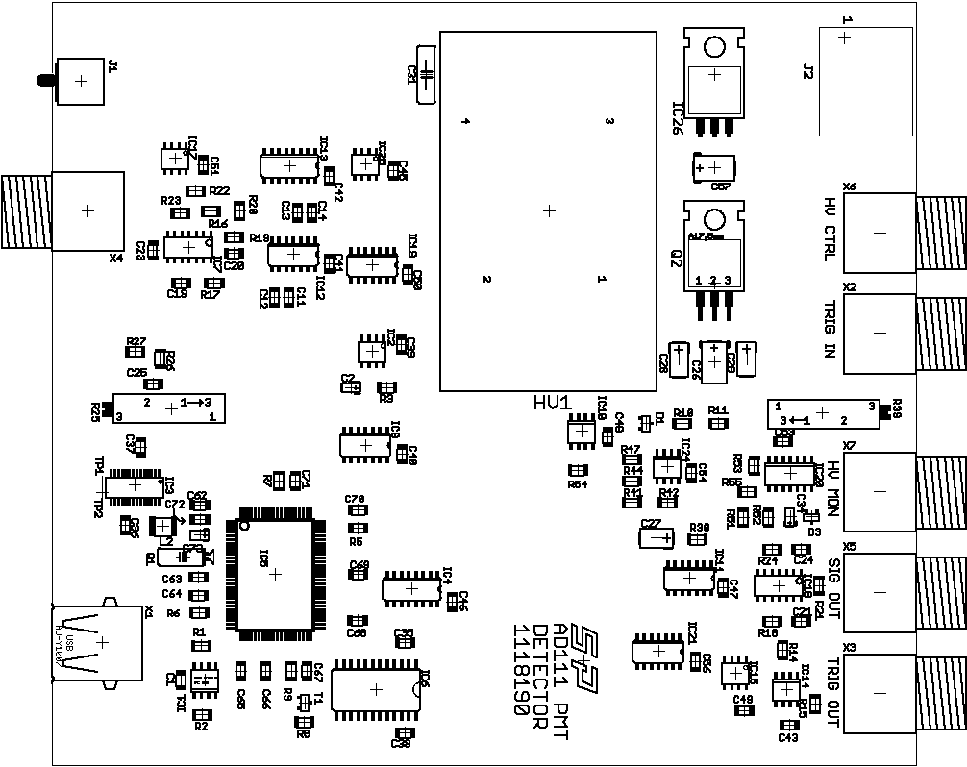
Figure 15. PC Board Layout

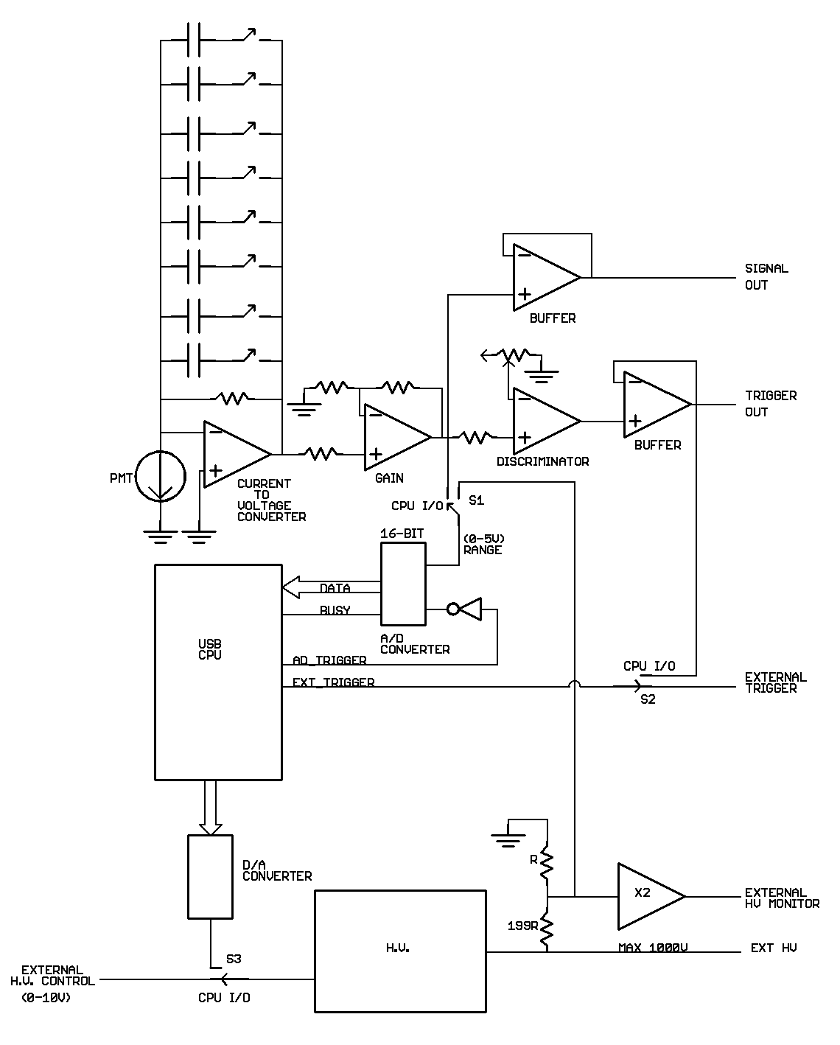

RC Constant

Figure 16. Block Diagram

Appendix C: SP SDK Functions

C.1. Some basic fundamentals of utilizing the SP SDK functions

First spTestBoard() should be called to get and set the appropriate information of the board. Then
spSetHv(), spSetRC(),spSetGain(), spSetTrigLevel(), spSetTrigSource(), spHvSource(), spSetAvg(). For AD111 status, call spReadInfo(), and for data, call spReadDataEx(). For the last function to call before exiting the AD111 software, call spCloseEx().

C.2. SDK Function Descriptions

spTestBoard
short spTestBoard
(
)

This function is used to check the status of the electronic board and its connection.

RETURN
If the function was done successfully, then it returns zero. If not, then it returns a nonzero number.

spCloseEx
void spCloseEx
(
)

This function is called to close the USB board. It should be called when exiting the application.

RETURN
None

spSetHv
short spSetHv
(
short sHV
)

This function is called to set the high voltage (1-1000v)

RETURN
If the function was done successfully, then it returns zero. If not, then it returns a nonzero number.

spSetRC
short spSetRC
(
short sRC
)

This function is called to set the time constant.
sRC can be 1 μs, 10 μs, 100 μs, 1 ms, and 10 ms (0-4).

RETURN
If the function was done successfully, then it returns zero. If not, then it returns a nonzero number.

spSetGain
short spSetGain
(
short sGain
)

This function is called to set the gain.
sGain can be from 1 to 10

RETURN
If the function was done successfully, then it returns zero. If not, then it returns a nonzero number.

spSetTrigLevel
short spSetRC
(
short sTrigValue
)

This function is called to set the voltage trigger level.
sTrigValue can be from 0 to 50, which correspond to (0-5v).

RETURN
If the function was done successfully, then it returns zero. If not, then it returns a nonzero number.

spSetTrigSource
short spSetTrigSource
(
short sTrigSource
)

This function is called to set the voltage trigger source.
sTrigValue can be from 0 to 2, which are External, Level, and Software.

RETURN
If the function was done successfully, then it returns zero. If not, then it returns a nonzero number.

spHvSource
short spHvSource
(
short sHvSource
)

This function is called to set the source of high voltage.
sHvSource can be 0 for External high voltage control, or 1 for Software control

RETURN
If the function was done successfully, then it returns zero. If not, then it returns a nonzero number.

spMonSource
short spMonSource
(
short sMonSource
)

This function is called to read the signal or to monitor the high voltage.
sMonSource can be 0 for data signal, or 1 for monitoring the high voltage.

RETURN
If the function was done successfully, then it returns zero. If not, then it returns a nonzero number.

spSetAvg
short spSetAvg
(
short sAvg
)

This function is called to set the sample average.
sMonSource can be from 0 to 300.

RETURN
If the function was done successfully, then it returns zero. If not, then it returns a nonzero number.

spReadDataEx
short spReadDataEx
(
long *pArray
)

This function reads the data from USB port.
*pArray points to a data address. Its memory size should be one or bigger.

RETURN
If the function was done successfully, then it returns zero. If not, then it returns a nonzero number.

spReadInfo
short spReadDataEx
(
short *sRdInfo
)

This function reads the data saved in the Eeprom of the interfacing USB board. The data are the High voltage (HV), the RC constant, the Gain, the Trigger value, the Trigger source, the HV source, the HV control source, the firmware version, the DC power, and the sample average.
pArray[0...1] is the current high voltage, where HV = pArray[0]*256 + pArray[1].
pArray[2] is the RC time constant.
pArray[3] is the Gain.
pArray[4] is the Trigger value.
pArray[5] is the Trigger source.
pArray[6] is the HV source.
pArray[7] is either data or monitored HV.
pArray[8…9] is the firmware version in the format of pArray[8].pArray[9].
pArray[10] is DC voltage indicator, where 0: not DC, 1: yes DC.
pArray[11…12] is the sample average (SA), where SA = pArray[11]*256 + pArray[12].

RETURN
If the function was done successfully, then it returns zero. If not, then it returns a nonzero number.

